

SCE-MI Transaction Protocol Proposal

Cadence Design Systems, Inc.
August 14, 2003

Abstract

This document describes Cadence Design Systems’ proposal to add a transaction-level interface (TLI) to the Accellera SCE-MI standard.

The proposed TLI will enable reusability of HDL design components across multiple design/verification environments. In particular, the TLI supports a generic transaction-level interface that can be supported in simulation, emulation and hybrid environments, with underlying execution engines that are either cycle-based or event-based. The TLI is a design-centric protocol which hides the underlying details of the verification tools and environment from the writers of HDL verification components.

Figure 1 provides a simple comparison of a SCE-MI-based co-emulation environment, and a TLI-based co-verification environment. The white boxes in the diagram represent the public interfaces of SCE-MI and the proposed TLI. The darkest boxes in the diagram represent user-created IP. The lighter shaded objects are vendor-specific environment components. The partial shading of the HW SIDE of the SCE-MI diagram illustrates the link/dependency that the SCE-MI clocking scheme has on the emulation environment.

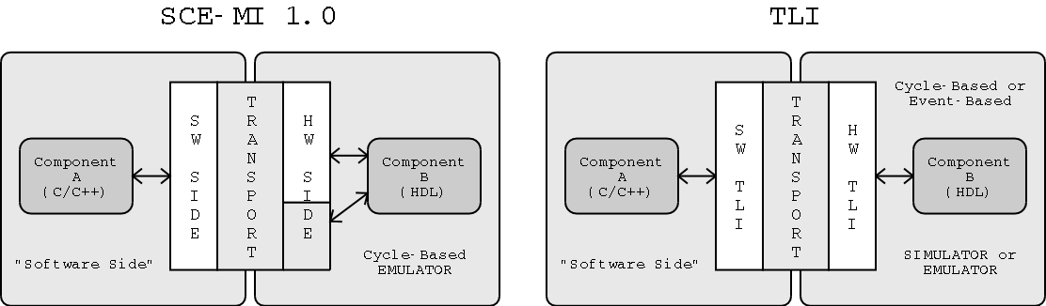
Figure 1: Comparison of SCE-MI and Proposed TLI

The core of the TLI is a transaction data transport definition, with corresponding HDL and C/C++ interface representations. The SW TLI and HW TLI layers represent the proposed C/C++ and HDL interfaces, respectively. The vendor-specific TRANSPORT layer is hidden underneath the TLI protocol presented by the SW TLI and HW TLI layers.
The transport definition is simple, in order to facilitate easy integration of the TLI into existing HDL components and software environments. The TLI proposal also includes a flexible definition of a transaction, allowing parameterization of transaction data to match physical bus protocols and HDL transactor capabilities, and to accommodate variable-length transactions of arbitrary size.

The TLI proposal implies the following additions/changes to the existing SCE-MI standard:

- Standard definition of a transaction, and transaction data
- Addition of Transaction-Level port macro(s)
- Definition of Transaction-Level ‘bus protocol’, including data transfer and runtime configuration
- Removal of requirement for clock port and clock control macros, and associated role of infrastructure linker in identifying and interpreting such macros
- A proposed change to the SCE acronym, to better represent the verification-environment-neutral nature of the TLI

This proposal is limited to the definition of a transaction-level transport mechanism and the associated software and HDL interfaces. Overall verification system control and synchronization lies outside the scope of this proposal. The protocol and its C/C++ interfaces are designed to be flexible, to be utilized in conjunction with a choice of higher-level design languages and in a variety of verification scenarios and environments.

Standard Co-Emulation Modeling Interface
Hardware Description Language
containing both simulation and emulation technology
The proposed TLI addresses deficiencies outlined in “Applying the SCE-MI to event-based systems” in the SCE-MI 1.0 specification
The underlying transport of the proposed TLI could be based on/implemented using SCE-MI 1.0

