Objectives
This proposal elaborates VPI diagrams for checkers. The basic checker proposal is covered by Mantis 1900.
36.4 Module
REPLACE
WITH
Note to the editor: Only modified part is shown.
36.5 Interface
REPLACE
WITH
Note to the editor: Only modified part is shown.
36.8 Program
REPLACE
WITH
Note to the editor: Only modified part is shown.
36.9a (section to be renumbered by editor) Checker
Note to the editor: Please, shift the numeration of the subsequent clauses accordingly.

vpiDefaultDisableIff

vpiInstance

checker

cont assign
process

instance array

expr
distribution
checker

checker array

prop formal decl
clocking block

vpiGlobalClocking

clocking block

vpiDefaultClocking

expr

vpiIndex
Details:
- If a checker is an element within an instance array, the vpiIndex transition is used to access the index within the array. If a checker is not part of an instance array, this transition shall return NULL.

36.9b (section to be renumbered by editor) Instance
CHANGE TO
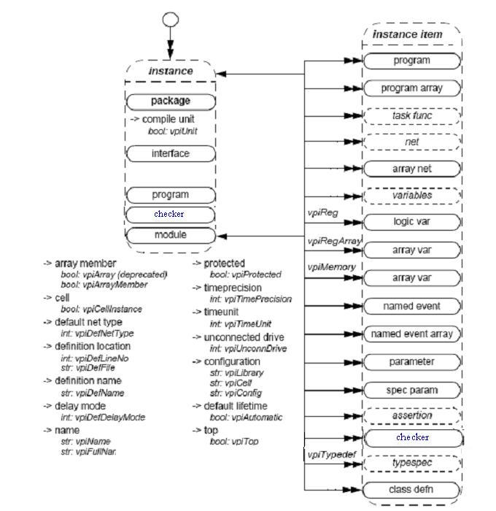

36.10 Instance arrays
REPLACE
WITH
checker array

36.16 Variables
ADD to the property list
-> CheckQualifier
int: vpiCheckQualifier
ADD to Details
Insert appropriate number here) A value of vpiNoCheck for the property vpiCheckQualifier shall indicate that the variable is a regular variable. A value of vpiCheck shall indicate that the variable is a regular checker variable. A value of vpiFreeCheck shall indicate that the variable is a free checker variable (see 16.18.6).
36.51 Atomic Statements
REPLACE
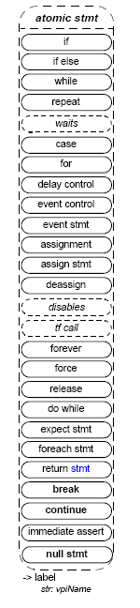
WITH
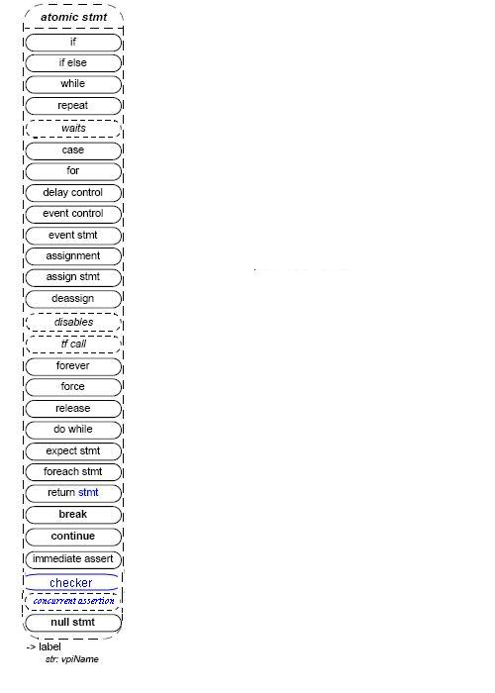
36.53 Process
REPLACE

-> always type
bool: vpiAlwaysType
WITH

-> always type
boolint: vpiAlwaysType
-> initial type
int: vpiInitialType
REPLACE
Details:
- vpiAlwaysType can be one of vpiAlways, vpiAlwaysComb, vpiAlwaysFF, or vpiAlwaysLatch.
WITH
Details:
- vpiAlwaysType can be one of vpiAlways, vpiAlwaysComb, vpiAlwaysFF, or vpiAlwaysLatch, or vpiAlwaysCheck.
- vpiInitialType can be one of vpiInitial, vpiInitialCheck.
36.75 Generates
REPLACE
WITH
Note to the editor: Only modified part is shown.
M.2 Source code
REPLACE
#define vpiProgram 602
WITH
#define vpiProgram 602
#define vpiChecker Editor to fill
REPLACE
#define vpiProgramArray 604
WITH
#define vpiProgramArray 604
#define vpiCheckerArray Editor to fill
REPLACE
#define vpiConstantVariable 612
#define vpiStructUnionMember 615
WITH
#define vpiConstantVariable 612
#define vpiStructUnionMember 615
#define vpiCheckQualifier Editor to fill
#define vpiNoCheck 1
#define vpiCheck 2
#define vpiFreeCheck 3
REPLACE
#define vpiAlwaysType 624
#define vpiAlwaysComb 2
#define vpiAlwaysFF 3
#define vpiAlwaysLatch 4
WITH
#define vpiAlwaysType 624
#define vpiAlwaysComb 2
#define vpiAlwaysFF 3
#define vpiAlwaysLatch 4
#define vpiAlwaysCheck Editor to fill
#define vpiInitialType Editor to fill
#define vpiInitialCheck Editor to fill

