LogiBLOX Lab

LogiBLOX Lab

Introduction

This lab uses the WATCH project, which is designed to be a track coach’s stopwatch (refer to Figure 1). There are two inputs to the system (RESET and STRTSTP). The configuration clock on the device is used as a ten-hertz clock signal. This system generates three seven-bit outputs for output to three seven-segment displays.
This lab reqiures you to use the LogiBLOX GUI to create the TENTHS component and add it to the design schematic using the Foundation software. In a later lab, you will finish the design and use the Xilinx M1 software to generate a bitstream for configuring the FPGA Demo Board for visual verification.

Design Description

The WATCH project contains some basic digital components that will be implemented in an XC4003E-3 FPGA using the Xilinx M1 Software (see Figure 1). This design contains 4-bit counters, a state machine, and a hex-to-seven segment decoder written in VHDL. This design also has the necessary elements to utilize the configuration clock signal.
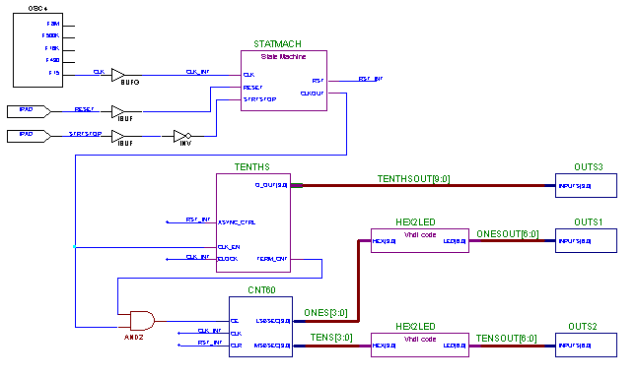

Figure 1. The WATCH Project

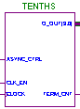 You can easily optimize the TENTHS LogiBLOX component for the XC4000E family by choosing the appropriate options from the LogiBLOX GUI. You will create and add this component to the WATCH project as part of this lab.

The OSC4 component is an internal 5-Frequency Clock-Signal Generator that provides an internal clock signal in applications where clock frequency accuracy is not critical, such as in this design. The available frequencies are determined by the FPGA components, which are process dependent, and therefore, vary from device to device. Nominal frequencies are listed on the primitive.
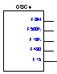

HEX2LED is a hex-to-seven segment decoder that was created in Foundation using the HDL Editor. Once the text file was entered, a symbol was created for it and the symbol was added to the project library. Once the library element is created, the element can be added to the schematic and it’s functionality verified
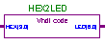
The CNT60 component is a combination of two 4-bit counters used to count from zero to sixty to generate the minutes and seconds of the WATCH project. This component was made with Xilinx Unified Library components that are pre-optimized for the XC4000E architecture.
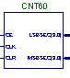

Procedure

Open an existing project within the Foundation Project Manager

- Open the Foundation Project Manager by clicking on Start -> Programs -> Xilinx Foundation Series -> Foundation Project Manager.

- Use the menu command: File -> Open Project.

- Go to the c:\m1labs\lgblox directory by double-clicking on “..” until the root directory is selected, and then double-click on the m1labs\lgblox directory. Click on the WATCH project and click on the Open button.

Create the TENTHS LogiBLOX component

- From the Foundation Project Manager, use the menu command: Tools -> Design Entry -> LogiBLOX module generator to start the LogiBLOX GUI.

- Create a 10-bit one-hot encoded counter that resets automatically at nine by selecting a Module Type of Counters, a bus width of 10, and entering a Module Name of TENTHS.

- Assert the Clock Enable port and the Asynchronous Control port. Since there is no need to load this counter, deassert the D_IN box. Likewise, since this counter will generate a carry out signal when it reaches the terminal count, assert the Terminal Count box.

- Set the counter’s Operation to UP, the Style to Maximum Speed, and the Encoding to One-Hot.

- Finally, since the stop watch must be externally resetable, create an asynchronous clear on the counter by setting the Asynchronous Value to 0000000001. Since the counter is one-hot encoded, one register must be assigned a value of 1 to denote a zero.

- After entering this information, the LogiBLOX Module Selector dialog box should look like Figure 2.

- Once the appropriate selections and details have been entered into the LogiBLOX Module Selector dialog box, click on the OK button.

- The LogiBLOX GUI will then ask if you wish to overwrite the existing tenths module. Click on the OK button in the message window.

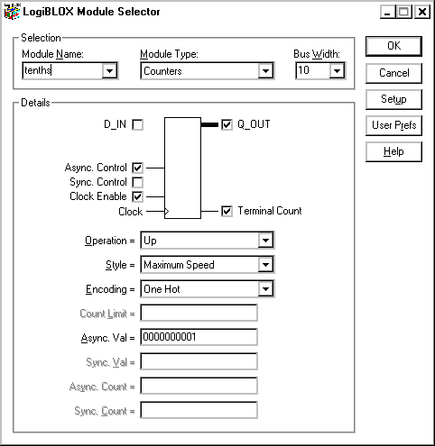
Figure 2. The TENTHS component in the LogiBLOX GUI.

- This will generate an EDIF netlist, create a symbol for the TENTHS macro, and attach the necessary files to the WATCH project library.

- Once this is completed, the TENTHS macro can be entered into the WATCH schematic.

Add the TENTHS LogiBLOX component to the WATCH project

- From the Foundation Project Manager open the Schematic Editor by using the menu command Tools -> Design Entry -> Schematic Editor.

- Once the program has started, click on the Symbols Toolbox icon on the vertical toolbar. This will open the SC Symbols box, which now contains the TENTHS component.

- Find the TENTHS symbol in the SC Symbols box by scrolling through the list of symbols, or enter the name at the bottom of the Symbols Toolbox (see figure 3). After finding the TENTHS symbol, click on the TENTHS symbol, move the pointer into the work area, and place the symbol as shown in Figure 4, by clicking the left mouse button.
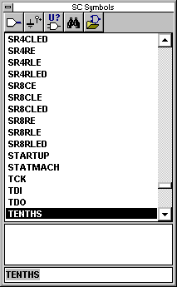

Figure 3. Using the Symbols Toolbox.

After placing the TENTHS symbol on the schematic, select the symbol by clicking on it, connect it to the existing wires by clicking on the Connect Symbol button on the horizontal toolbar. Click on the ESC button to exit design entry mode.

Save the finished schematic by using the menu command: File -> Save. Exit the Schematic Editor with the command: File -> Exit.

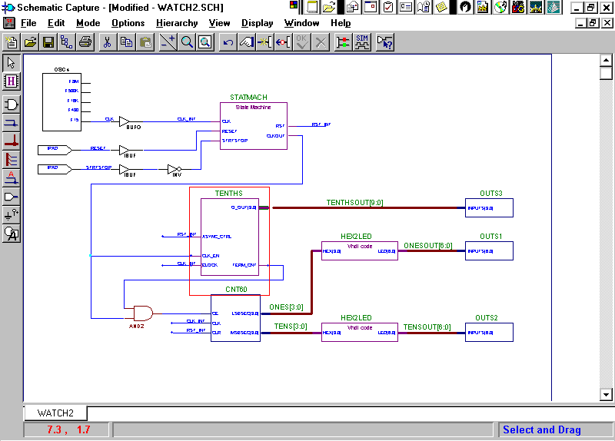

Figure 4. Placement of the TENTHS component.

Questions (Answers are in the Solutions section at the end of lab manual)

- How do you choose to have Carry Logic utilized in the TENTHS counter?

- Where can you find more information about the unique counter styles that are possible with the LogiBLOX GUI?

Conclusion

This laboratory demonstrates how to incorporate a LogiBLOX component in a design using the LogiBLOX GUI.

