Basic Timing Constraints Lab

Basic Timing Constraints Lab

Introduction

This lab uses basic timing constraints to improve the performance of the WATCH project. The purpose of this lab is to provide students the opportunity to use the Constraints Editor to improve design performance.

Previously, the WATCH project contained the OSC4 symbol to generate an internal clock signal. This version of the project gets the clock signal from an I/O pin, which enables the Period and Offset constraints to be used (see Figure 1).

In this lab, you will use the PERIOD and OFFSET global constraints to improve the system clock frequency of the project with little effort. The PERIOD constraint minimizes all paths between synchronous elements (registers, latches, and RAMs). The OFFSET constraint minimizes all paths between pads and synchronous elements, while taking the clock buffer delay into consideration.

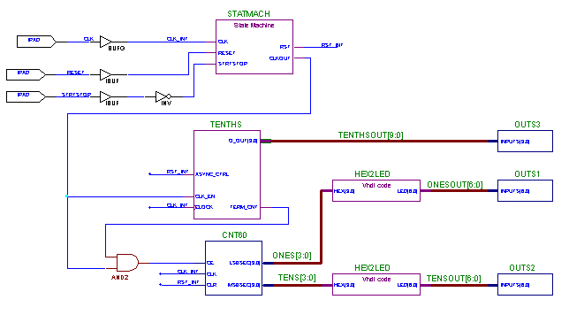
Figure 1. The WATCH project within the c:\m1labs\timing directory.

You will implement this design in an XC4003E-3 device. The project specifications require the design to perform at 28Mhz with pin assignments. The design will be implemented with 50ns (20 Mhz) global timing constraints. However, since the FPGA will be placed on a board with other devices, the external delays for these devices will be used to make effective timing constraints for the FPGA. In this lab, assume that the upstream device creates an external delay of 10ns, and that the downstream device creates an external delay of 5ns. With these external delays taken into account, the Offset In constraint should be 40ns, and the Offset Out constraint will be 45ns.

After implementation, you will review the Logic Level Timing Report to verify that the timing constraints are realistic. You will then shorten the global timing constraints to 40ns (25 Mhz) and reimplement the design. Eventually you will shorten the timing constraints to 38ns (26 Mhz) to meet the design goals.

It is important to remember that any projects’ system clock frequency is determined by the longest delay between synchronous elements on the entire circuit board. Since there is an external input delay of 10ns and an external output delay of 5ns, you will have to add these delays to the offset delays to determine the System Clock Frequency.

Example:

 | PERIOD constraint | OFFSET IN constraint | OFFSET OUT constraint | System Clock Frequency
1st TimeSpec  With Pins | 40 ns | 30 ns | 35 ns | 25 Mhz
Longest Path | 20 ns | 10 ns + 10ns | 30 ns + 5 ns | 1/35ns =29Mhz

From this example, you see that the OFFSET OUT constraint minimizes the path that limits the system clock frequency. This longest path is our designs’ “critical path”.

Procedure

Open the WATCH project within Foundation

- Open the Foundation Project Manager by clicking on Start -> Programs -> Foundation Series -> Foundation Project Manager.

- Use the menu command: File -> Open Project

- Go to the c:\m1labs\btc directory by double-clicking on “..” until the root directory is selected, and then double-click on the m1labs\btc directory. Click on the Watch project and click on the Open button.

- In the Foundation Project Manager window, open the Schematic Editor by using the menu command: Tools -> Design Entry -> Schematic Editor.

- Note that an input pin (see Figure 1) has replaced the OSC4 symbol. This allows the user to place timing constraints on the clock signal. When finished, close the Schematic Editor.

Implementing the WATCH project within the M1 software

- Start the M1 software from the Foundation Project Manager by using the menu command: Implementation -> Implement Design. If the tools ask you to update the netlist from the Schematic Editor, click on “Yes”.

- The Project Manager will prompt for the target device by bringing up the Implement Design window. Click on the Options button in the Implement Design window to open the Options dialog box. Associate the proper User Constraints File by browsing for the c:\m1labs\watch.UCF. After this file has been found, click on OK to exit the Options dialog box and click on Run button in the Implement Design window. This will start the implementation process and bring up the Flow Engine.

- While the design is being processed, monitor the implementation progress through the Flow Engine’s Message window at the bottom of the Flow Engine.

- After a first implementation has been completed, constraints can be added to the design with the Constraints Editor.

Creating Timing Constraints using the Constraints Editor

- Open the Constraint Editor by using the menu command: Start -> Programs -> Xilinx Foundation Series -> Accessories -> Constraints Editor.

- Once the editor is open, use the menu command: File -> Open to select the Watch.UCF from the c:\m1labs\btc directory. When the Open Design File window comes up select the Watch.NGD file from the c:\m1labs\btc\xproj\ver1\rev1 directory.

- Enter a 50ns period on the clock signal by clicking on the Global tab and double-clicking on the box below the Period column heading. This will open the Clock Period dialog box as seen in Figure 2. Enter a time of 50ns and click on the OK button.

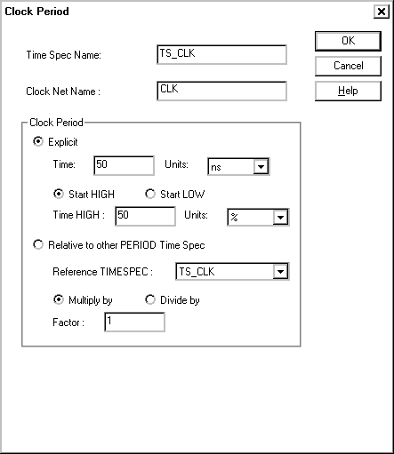
Figure 2. The Clock Period dialog box set for a 50ns period.

- Click on the Ports tab. Enter a Clock to Pad constraint (Offset Out constraint) of 45ns for each output path associated with the ONESOUT and TENSOUT busses by double clicking on each box below the Clock to Pad column heading.

- Enter a Pad to Setup constraint of 40ns for each input pin associated with the RESET and STRTSTOP input pins by double-clicking on each box below the Pad to Setup column heading. This will create Offset In constraints in your User Constraints File.

- Save constraints by using the command: File -> Save.

- Exit the Constraints Editor.

Implementing the WATCH project with Timing Constraints

- In the Foundation Project Manager window click on the Versions tab and use the menu command: Project -> Create Revision. When the New Revision window opens, click on the OK button.

- Use the command: Implementation -> Implement Design to implement the design with timing constraints. When the Implement Design window opens click on the Options button. This will open the Options dialog box.

- In the Options dialog box, click on the Edit Template button next to the Implementation box. Click on the Timing Reports tab, and assert the Produce Logic Level Timing Report option. This will cause the Flow Engine to generate a report that verifies each timing constraint is reasonable.

- Click on OK in the Timing Reports tab. Click on OK in the Options box. When the Implement Design window opens select the option to “overwrite current revision…”. Click on Run in the Implement window to start the implementation process and bring up the Flow Engine window.

Verifying Timing Constraints with the Logic Level Timing Report

- Open the Report Browser by using the menu command: Utilities -> Report Browser. When the Logic Level Timing Report becomes available, verify that none of the paths reported are longer than their corresponding constraint.

- Complete the chart for the Logic Level row in the Questions section of this lab.

Analyzing the Results with the Timing Analyzer

- From the Foundation Project Manager start the Timing Analyzer by using the menu command: Tools -> Simulation/Verification -> Interactive Timing Analyzer.

- To determine if the implementation met the timing constraints click on the “TC?” button, or use the menu command: Analyze -> Timing Constraints to generate the Timing Constraints Analysis Report.

- Review the contents of this report, complete the chart for the 1st TimeSpec row, and answer the questions in the Questions section of this lab.

Questions (Answers are in the Solutions section at the end of the lab manual)

 | PERIOD constraint | OFFSET IN constraint | OFFSET OUT constraint | System Clock Frequency
1st TimeSpec | 50 ns | 40 ns | 45 ns | 20 Mhz

Logic Level

Longest Path
2nd TimeSpec | 40 ns | 30 ns | 35 ns | 25 Mhz

Longest Path
3rd TimeSpec | 38 ns | 28 ns | 33 ns | 26 Mhz
Longest Path

- Which timing specification limits the system clock frequency?

- What is the Maximum Frequency reported in the Timing Constraints report?

- Why is the Maximum Frequency reported by the Timing Analyzer different from the System Clock Frequency?

- After reviewing the Timing Constraints report and the project schematic, which component do you believe causes the longest delay path?

- Replace the timing specifications in the Constraints Editor with the timing specifications given in the chart for the second and third implementations. After each modification, reimplement the project to see if better performance can be achieved. Complete the chart after each successive implementation.

- After completing the last implementation, can you think of any other ways to improve the System Clock Frequency?

Conclusion

In this lab, Timing Constraints are used as the primary way of communicating a performance expectation to the M1 software. Even though using constraints is not the only way, they are the best method of getting high performance and utilization. Xilinx recommends that timing constraints be entered using the Constraints Editor.

