Xilinx Distributor FAE Training - September 1998

Floorplanner Lab

Objective :
Learn how the floorplanner works within the M1 flow. Study examples of various floorplanning techniques, learn where the floorplanner is useful, understand some of the limitations of the current floorplanner.

Process overview:
The main objective of this lab is to teach you the basics of the floorplanner design flow.

Additionally, for those of you that wish to learn more about the floorplanning process, there are two optional sections that can be covered on your own time.

Learning the basics of the floorplanner design flow
In this section, you will learn the steps to integrate the floorplanner into an M1-based design. You will also learn the basic principles of operation of the Floorplanner GUI, and how to manipulate the design on at the “BEL-level”. You will also learn how to use the Floorplanner as a means to view a placed and routed design.

As shown in the introductory presentation slides, the floorplanner uses design.ngd and design.ncd (mapped) as its input files. After the user completes manipulation of the design elements within the GUI, the save operation outputs design.fnf and design.mfp. design.mfp contains BEL placement and CLB packing information and is then used as an input file to a second run of the mapper. PAR can then be run as normal. The important point to remember is that MAP needs to be run twice for each design iteration involving the floorplanner.

To floorplan a design, the design needs to first be processed as normal through the translation (ngdbuild) and mapping (map) steps. After mapping, if you are familiar with the design’s “structure”, you can immediately start floorplanning, It is often easier to first place and route the design (PAR) and then use the floorplanner to modify the placement – this is the flow that will be shown here.

The design calc_r.ncd has already been placed and routed. You will use the floorplanner to modify this design.

[NOTE: Although this lab has been written from the perspective of running the tools from the command line (e.g. MS-DOS prompt), the floorplanner can also be invoked from within the normal Design Manager/Flow Engine. There is an application note that describes the details of using the floorplanner from the DM/FE.]

Start of lab:

- Invoke the Design Manager:
Start -> Programs -> Xilinx Foundation Series -> Accessories -> Design Manager.
- Open a project using the pulldown menu: File -> Open Project
- Push the Browse button, a browser window will appear.
- Browse to:
C: -> {your directory path} -> ximpl -> fplanlabs_d -> calc_fp -> xproj -> calc.xpj. Push the Open button in the Browse window to open calc.xpj. Push the Yes button when asked if you want to add this project to the project list. Push the Open button in the Open Project window to open the project.
- Expand the design hierarchy view for ver1.

- Select rev1, and invoke the floorplanner from the Tools -> Floorplanner pulldown menu item. The floorplanner will read in the .ngd and .ncd files.

The Floorplanner will present you with four windows:
- Design Hierarchy
- Design Nets
- Floorplan View
- Placement View (this is “cascaded” behind the Floorplan View)
If the input .ncd was not a placed version, there would be no Placement view. To best see all the windows, you should use the “Tile Compare” view.

- Use the Window->Tile Compare pulldown menu selection. The placement view and floorplan view are now displayed side-by-side.

Note that the floorplan view already has some placed components – though we have not yet done any manual floorplanning

Questions:
- What types of components are “pre-placed” in the floorplan view of the design?
- Given that this design has not been previously “floorplanned”, how do you suppose these components came to exist in the floorplan view?

Manipulation of the floorplan is quite easy. You can select BELs, groups of BELs, or RPMs from the Design Hierarchy window and drag them to sites within the Floorplan window.

- To illustrate this process, select the icon-stack group LIFO/16X4 “RAM16X4S” (shown below) from the Design Hierarchy window and “drag” it to the Floorplan window. Note how the ratsnests automatically show the connectivity of this block of logic to the I/Os.

- Drag the group back to the Design Hierarchy window – this effectively removes it from the floorplan window. Expand the hierarchy for this logical group by clicking on the “+” symbol for this group (similar to the hierarchy display of Windows Explorer). This will expose the individual RAM elements. Select one of these, say LIFO/16X4/03 “RAM16”, again by clicking on the icon. Place it in the Floorplan window as an independent BEL.
- RPMs behave differently. Scroll down the Design Hierarchy window until you find the block labeled ARITH/ADDSUB/hset “RPM”. Expand this block. Note how the individual BELs are not selectable for this RPM. The RPM can only be floorplanned as an entire unit as the floorplanner will recognize and preserve the RLOC information of all RPMs and carry chain configurations. Try moving the whole RPM to the floorplan. This illustrates how you can use the floorplan to visualize the shape of an RPM.

Since this design has already been placed and routed, as is shown in the Placement Window, we can use this as our starting point. To do this:

- Select the Floorplan->Replace all with Placement pulldown menu item. Note how the actual placement information is now “imposed” on the floorplan.
- Modify the floorplan by moving some of the BELs, I/Os or RPMs. (Don’t do too much, we need you to get through this lab as quickly as possible).
- Select the Floorplan->Check Floorplan to verify that the moves you have made are legal (this checks for things like broken carry chains, illegal CLB packs, etc…)
- Save the floorplan by doing a File->Save. This will write out calc.fnf and calc.mfp. Leave the Floorplanner window open.

We now need to re-run the mapping and place/route phases of the implementation tools to incorporate the floorplan.

- In the Design Manager window, make sure rev1 is still selected and invoke the Design -> Set Floorplan File(s)… pulldown menu item.
- Change the Floorplan Design option to Custom.
- Another dialog box will appear. In the Floorplanning File: box, use the browser to specify:
c: ->{your directory path} -> ximpl -> fplanlabs_d -> calc_fp -> xproj -> ver1 -> rev1 -> calc.fnf.
- Specify calc.mfp in the Floorplanned Guide File: box, and click OK twice to return to the Design Manager main window.
- Re-invoke the Flow Engine on this revision. Set the implementation state back two steps by clicking on the button twice. Only the Translate state should be marked now as Completed.
- Use the Utilities -> Command Preview pulldown menu item to see the command line that will be issued when Map is re-run.
Question:
- Compared to the previous invocation of Map, what is different about this command line?

You can now verify how the floorplan has affected the placement

- Press the “Play” button to run the design through MAP and PAR.
- When the PAR job has finished, back in the Floorplanner window, you can now view the placement by doing a File->Update. Specify calc.ncd and calc.ngd. The Placement window should now reflect the changes you made in the Floorplan window.
- Exit the Floorplanner and Design Manager (File->Exit).

Part 2: Understanding Floorplanning of a “structured” Design (PCI core)
You will now look at a design that contains the PCI LogiCore. The timing constraint for this design is a single 30ns clock period.

In the c:\{your directory path}\ximpl\fplanlabs_d\struct_nofp directory, this design was run without any (floorplanner created) placement constraints.

- Using a text editor such as WordPad, inspect the PAR output file, pci_top_r.par.

Questions:
- What is the target device for this design?
- What was the PAR effort level?
- How much CPU runtime was used?
- What was the final timing score?
- How much (negative) timing slack was there?

As you can see, this design fell just short of meeting timing, even after a comparatively “high effort” PAR run. It is possible to invoke other cost tables which will in fact lead to a design that does meet timing, but at a cost of some relatively long runtimes.

We know this design has logic which can be considered to be quite “structured” in its nature. Datapath alignment and I/O placement are critical to obtaining a good result when the timing constraints are difficult to meet. We can take advantage of the floorplanner to layout the critical portions of this design.

In the c:\{your directory path}\ximpl\fplanlabs_d\struct_fp directory, we have created a floorplanned version of this design.

- Invoke the floorplanner directly:

Start -> Programs -> Xilinx Foundation Series -> Accessories -> Floorplanner
- Use File->Open to open c:\{your directory path}\ximpl\fplanlabs_d\struct_fp pci_top.fnf. The floorplanner will ask you if you wish to update the floorplan with a new set of design files – click on the No button. When the floorplanner comes up, you may wish to resize the window to a larger size to ease viewing the design.
- Select a portion of the logic in the Floorplan window by dragging the mouse pointer over a region of the design while holding the left mouse button down. For example, select an area that roughly corresponds to the lower-right “quadrant” of the chip. It should produce a result that looks like:
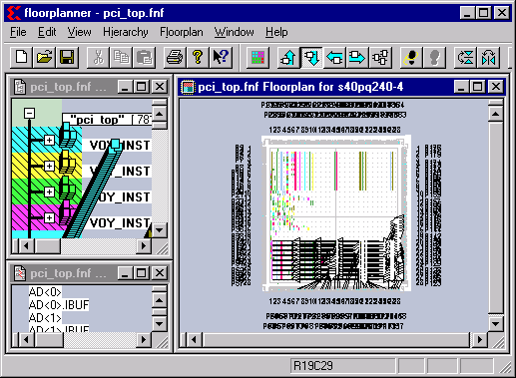

By looking at the ratsnest displayed, you can see quite clearly how the user of floorplanner has laid out the datapath structures in perfect alignment. Moreover, it is easy to see in this view that the I/Os associated with this datapath are also positioned in close proximity to the CLB to which they are connected.

- Select other pieces of the logic to see how things have been structured in this floorplan. In addition to the datapath structures, the left-center region of the chip contains the PCI control logic.
- Again using an editor such as WordPad, inspect the PAR report file, pci_top_fpr.par.
Questions:
- Which file contains the constraints that tell PAR where to place the floorplanned logic?
- How much CPU runtime was used?
- What was the final timing score?
- How much (positive) timing slack was there?

As you can see from the results of the PAR run that included floorplanning information, runtime was dramatically reduced and timing was easily met.

- Back in the Floorplanner, view the placement by doing a File->Update. Specify c:\{your directory path}\ximpl\fplanlabs_d\struct_fp\pci_top_fpr.ncd and pci_top.ngd.
- Use the Window->Tile Compare pulldown menu selection. You can now view how the remainder of the logic was placed (automatically by PAR) within the framework established during floorplanning.

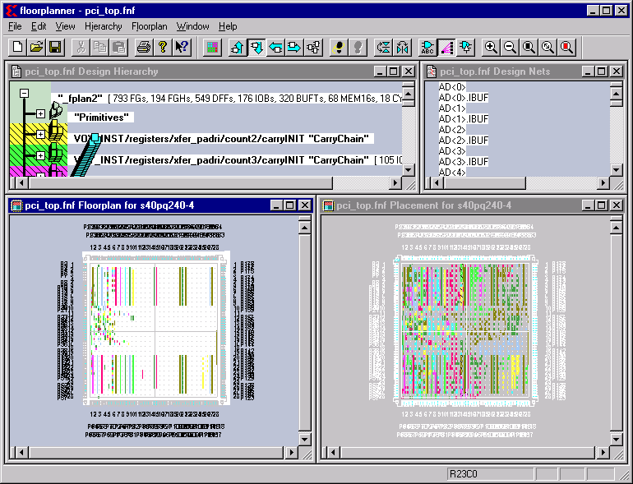

This is an example of a design that has some characteristics that make it a good candidate for floorplanning:

- The designer had detailed knowledge of the specifics of the target architecture/part.
- The designer had detailed knowledge of the specifics of the design being implemented.
- It was a design that had structures that were well suited to this sort of detailed, BEL-level floorplanning.
- The designer was willing and capable of iterating over the floorplan multiple times to achieve the desired results.
- Performance and density goals that are realistic.

It is important to note here that not all designs will benefit from floorplanning. It should be the case that the vast majority of designs will not need to be floorplanned in this manner, as the normal tool flows are be adequate the vast majority of the time. It will take experience to develop the skills required to know if floorplanning is an appropriate tool to use for any given design.

- Exit the floorplanner.

You have now completed the main part of this lab. The following section is optional and can be explored at a later time to learn more about the area-based floorplanning process.

OPTIONAL Part 3: Area-Based Floorplanning – a Prelude to Modular Design
FPGA design sizes are growing dramatically, and are now into the multiple hundreds of thousands of “system gates” – large by any standard. The cost of handling designs of such size is increased design effort and increased place and route runtime, often in exponential proportion (at least) to the growth in the number of gates.

Expecting a place and route tool to handle a 250,000 gate design in a few hours is generally not realistic for most performance oriented designs.

Xilinx is actively investigating methods and techniques by which the problems of efficiently implementing large designs can be addressed. Among the most obvious of these are techniques that partition the large design into several smaller “sub-designs” which are in turn processed in a (relatively) independent manner.

Area-based Floorplanning is a method in which designers can use the Floorplanner to quickly assign the major modules of their designs to specific regions of the chip, effectively sub-dividing the problem for the mapping and place/route algorithms. This is distinctly different from the “BEL-level” style of floorplanning shown in the first two parts of this lab, where individual BELs are manually placed in specific sites on the FPGA.

Creating Area Groups Using the Floorplanner

- Invoke the Design Manager:
Start -> Programs -> Xilinx Foundation Series -> Accessories -> Design Manager.
- Open a project using the pulldown menu: File -> Open Project
- Push the Browse button, a browser window will appear.
- Browse to:
C: -> {your directory path} -> ximpl -> fplanlabs_d -> calc_fp -> xproj -> calc.xpj. Push the Open button in the Browse window to open calc.xpj. Push the Yes button when asked if you want to add this project to the project list. Push the Open button in the Open Project window to open the project. Note: The Design Manager may come up with this project already loaded if this was the last project you worked on - e.g. Part 1 of this lab.
- Expand the design hierarchy view for ver1.
- Select rev_area, and invoke the floorplanner from the Tools -> Floorplanner pulldown menu item.
- When the floorplanner has completed loading the design, go to the Design Hierarchy window and completely expand the hierarchical block labeled “Primitives”. Scroll down the list until you see the BEL named CONTROLLER/$1I462 and select that BEL (it’s an F/G lut) by clicking next to, but not on, the LUT symbol “icon stack”. (Clicking directly on the LUT symbol icon will cause it to “stick” to the mouse pointer, but we don’t want to actually move it at this time).
- Scroll down further in the same block to the BEL named $1I505/$1I5, holding down the Shift key, use the left mouse button to select that BEL. You should now have all the BELs between CONTROLLER/$1I462 and $1I505/$1I5 selected.
- Use Hierarchy->Group, which will place the selected BELs in their own, newly defined hierarchical group. It should contain 27 FGs and 12 FGHs. (If you don’t get exactly the same group, it doesn’t really matter. Just make sure the group you do create only contains FG and FGH elements. Other elements such as IOBs should not be part of this group.)
- Use the Edit->Properties on that group to rename it to “My_Group”.
- Collapse the hierarchy for “My_Group”, but make sure it’s still selected
- Use the Floorplan->Assign Area Constraint pulldown menu item (this can also be done by selecting the tool bar button:

- In the Floorplan window, “drag-out” a rectangular region covering about ½ of the chip’s CLB array.

The resulting floorplan should look like:

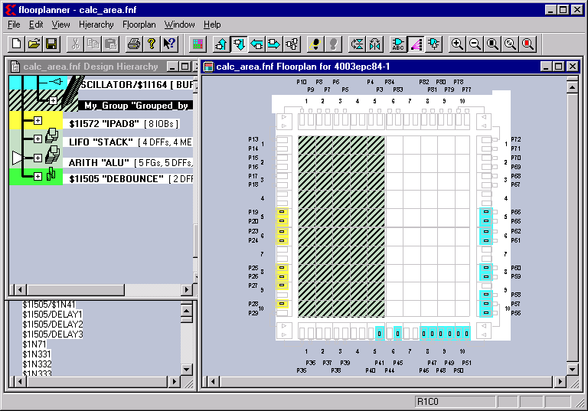

- Save the floorplan by doing a File->Save. This will write out calc.fnf and calc.mfp. Leave the Floorplanner window open.

We now need to re-run the mapping and place/route phases of the implementation tools to incorporate the floorplan.

- In the Design Manager window, make sure rev_area is still selected and invoke the Design -> Set Floorplan File(s)… pulldown menu item.
- Change the Floorplan Design option to Custom.
- Another dialog box will appear. In the Floorplanning File: box, use the browser to specify:
c: ->{your directory path} -> ximpl -> fplanlabs_d -> calc_fp -> xproj -> ver1 -> rev_area -> calc.fnf.
- Specify calc.mfp in the Floorplanned Guide File: box, and click OK twice to return to the Design Manager main window.
- Re-invoke the Flow Engine (Tools -> Flow Engine) on this revision. Set the implementation state back two steps by clicking on the button twice. Only the Translate state should be marked now as Completed.
- Press the “Play” button to run the design through MAP and PAR.
- When the PAR job has finished, back in the Floorplanner window, you can now view the placement by doing a File->Update. Specify calc.ncd and calc.ngd. The Placement window should now reflect the changes you made in the Floorplan window.

You can now verify how the floorplan has affected the placement

- Use the Window->Tile Compare pulldown menu selection. The placement view and floorplan view are now displayed side-by-side. The Placement window should now reflect the fact that the BELs that belong to “My_Group” are now located in the left half of the chip – verify this by selecting the group “My_Group” in the design hierarchy window.

You’ve just seen how to use the area-based floorplanning capability on a very simple design. Let’s now look a more realistic example.

- Close the existing floorplan by using File -> Close (you do not need to save the file).

- Use File -> Open to open c:\{your directory path}\ximpl\fplanlabs_d\area_fp\careap.fnf
- Click “No” when asked if you wish to update using new .ncd/.ngd files. Use the Window->Tile Compare pulldown menu selection once again to display the floorplan and actual placement side-by-side.

This design has several of it’s major hierarchical blocks floorplanned to relatively large regions of the chip: The large module that occupies most of the left half of the chip is named dwart_a and contains 947 F/G LUTs, 6 HLUTs and 303 DFFs. Notice how this module is contained within the region defined by the floorplan. Other modules are clearly visible, too. It takes very little time to create such a broad-level partition for such a design – even ones that are quite large.

- Zoom in near the top-middle region of the floorplan window. You will notice that on the rightmost “border” of the large dwart_a block, there is a bank of TBUFs (colored green/brown) placed within the module. Also you will notice another bank of TBUFs (in blue) nearly adjacent to the previous bank. Selecting individual TBUF BELs shows the ratsnest connections between these two banks of TBUFs.

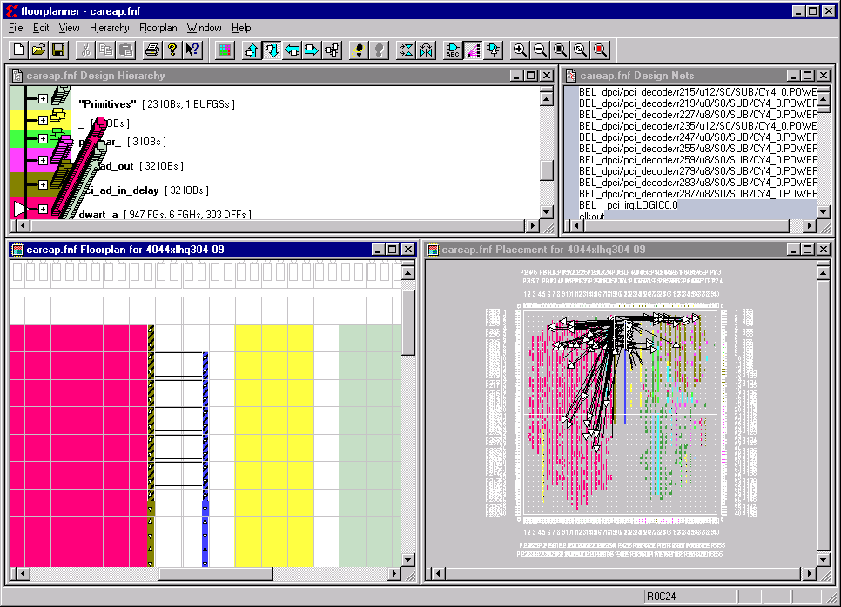
Question:
- From the example design shown, does it appear that “BEL-level” and “area-based” floorplanning have been intermixed?

As you can see, we have done a limited amount of BEL-based floorplanning within a design that has been largely floorplanned in the area-manner. This illustrates the fact that the two styles of floorplanning are not mutually exclusive and will often be inter-mixed in the same design.

In this design example, as with most such designs, the modules are not completely independent – there will always be some inter-module connections. Though PAR will generally handle the placement of the “communicating elements” in a reasonable manner, sometimes the connections are simple enough to manage that it would be good practice to just lock them down to specific sites.

To illustrate further, here is a “conceptual” picture of large (250xv) that has an even more sophisticated area-type floorplan:

At this point the area-based floorplanning mechanisms are still rather new. Users who are familiar with the properties of their designs (relative size, main communication channels between modules), should be able to take advantage of the partitioning capability of the floorplanner.

Some features we will be adding in the future releases will be:
- Better means to allow a user to estimate how big an area is required to fit a given module
- Resizing of modules
- Mechanisms to ensure that RPMs will be fully contained within a region.
- Auto-partitioning tools
- Exit the Floorplanner – this lab is now complete.

