IMPLEMENTING a

DEMODULATOR

using the
XILINX CORE GENERATOR

~ Answers ~
Date: 01/29/98 Sabine Lam

Lab 1: Numerically Controlled Oscillator (NCO) Implementation
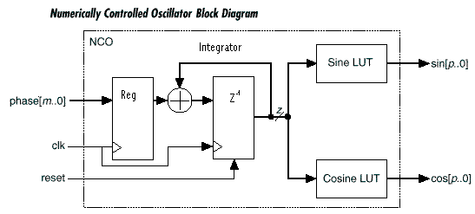
Q1) Are all the values that represent the Sine Wave Stored in the ROM Look-Up Table? If not, how much of it is stored?
No. The LUT stores only the values for the first quarter of the sine wave. Values of sine or Cosine are derived from this stored data by appropriate negations of the Theta input and the value fetched from the internal table.
Q2) How many CLBs is a 64 words by 10 bits Sine Table going to use?
14 CLBs
Q3) How many clock Latency?
3 clock latency.
Q4) Do you need to generate two separate modules for the Sine Table and the Cosine Table used in the NCO?
No. The quarter of the Sine wave is the same for Sine or Cosine. The table is internally addressed in a different order depending on the CTRL signal.
Q5) What Sine Wave are you getting if the Ctrl signal is:
ctrl=1 : Sin(theta)
ctrl=0 : Cos (Theta)

Simulation

The goal is to run two simulations with a different phase_offset value and compare the amplitude values that you get on the Sine and Cosine outputs. Put some Probes on the Phas_off[11:0], CE and CLK inputs as well as on the THETA inputs of each Trigonometric Tables and their SIN[9:0], COS[9:0] outputs.

S1) Load a phase_offset of 100 (hex) and clock the NCO until you start seeing some Sine and Cosine amplitude values. It is necessary to clock the NCO until the output of the Integrator is high enough to start driving the Theta input of the Sin/Cos table. Look at the Sin and Cos LUT outputs and save the 8 first values on the table below. The 8th value should be the same for COS and SIN, can you explain why?

S2) Now, rerun the simulation doubling the phase_offset value (load 200 (hex)). Compare the Sin and Cos outputs with the previous simulation and you should see that only every other amplitude values are now displayed. Can you explain why?

You are Done with Lab 1.
Lab 2: Multipliers
Q1) 8x8 Non-Pipelined KCM
Number of CLB used? 19 CLBs
Q2) 8x8 Pipelined KCM
Number of CLB used? 21 CLBs
Number of Clock Latency? 2 clks
Q3) 8x8 Speed Optimized Multiplier
Number of CLB used? 70 CLBs
Number of clock Latency? 4 clks
Performance in a –1 part? 97MHz
Q4) 8x8 Area Optimized Multiplier
Number of CLB used? 54 CLBs
Number of clock Latency? 4 clks
Performance in a –1 part? 83MHz
Q5) Compare the performance and the CLB count of a 8x16 and a 16x8 area optimized multiplier.
Which one is faster? 8x16 runs at 74MHz vs. 63MHz
Which one is bigger? 8x16 uses 124 CLBs vs. 98 CLBs
Q6) All the cores generated with Coregen are relatively placed. All the variable multipliers (NxM) are built to fit in a rectangular or square matrix of N rows by M (or M-1) columns.
What is the shape of a 8x16 multiplier? 8 Rows x 16 Cols
What is the shape of a 16x8 multiplier? 16 Rows x 8 Cols
Conclusion: The Short and Fat multiplier runs faster but is bigger than the Tall and Thin one. This should be taken in consideration when entering the A and B width of the multiplier.

2- Speed up the Area Optimized Multiplier
Requirements: 14x14 signed multiplier running at 75MHz in a XC4000E-1 part.
Design Overview
A regular 14x14 multiplier runs at 62MHz and uses 173 CLBs (see Data Sheet). In order to increase the speed of the Area Optimized Multiplier provided in the Xilinx Core Generator, it is possible to use two multipliers in parallel. Each multiplier processes one half of the data and their outputs are added together to produce the full resolution result.
Q1) What is the performance and the CLB count of a 7x14 multiplier?
Around 77 MHz
Q2) Does sign extending the number changes the value?
No. In two’s complement, 1011 is equivalent to 11111011
In order to verify, you can invert the number and add one:

1011 inverted becomes 0100 to which we add 1 : 0101 = 5

11111011 inverted becomes 00000100 to which we add 1 = 00000101 = 5

Q3) How many CLBs is this faster multiplier going to require?

The 7x14 multiplier requires around 100CLBs, the 8x14 uses 111CLBs and the 21 bit adder requires 11 CLBs.
Total: 100 + 111 + 11 = 222 CLBs

Q4) What is the limiting performance path? What can be done?
The last 21 bit adder is the limiting path. This adder can be split in half and pipelined.

- Complex Multiplier
Complex multipliers are often used in DSP application…
The implementation we are the most familiar with is the following:
(A + jB) (C + jD) = AC – BD + j(AD + BC)
where the Real side is Re = AC – BD
and the Imaginary is Im = AD + BC
This Complex multiplier requires 4 Multipliers, 1 subtractor and 1 adder which is pretty expensive as far as CLBs.
Q1) How many CLBs would be required to implement a 14x14 complex multiplier using this implementation?
4x173 + 1x14 + 1x14 = 720 CLBs
PS: This is keeping full resolution throughout the whole multiplier so the subtractor and adder are each of 28 bits. The rule of thumb for the adder and subtractor is 2 bit per CLBs so they each use 14 CLBs.
Q2) How many CLBs are now used for a 14x14 complex Multiplier with this new approach? (3 Multipliers, 3 adders and 2 subtractors
3x7 + 3x7 + 3x173 + 2x14 = 589 CLBs
PS1: The 2 first Adders and 1 subtractor are 14 bits only. Then the A, B and D data need to be pipelined once. Finally, the Adder and Subtractor on the output are 28 bits.
PS2: The pipeline stage on the output of the multipliers is not counted here since it is not mandatory to have it.

You are done with Lab 2!

LAB 3: Finite Impulse Response (FIR) filter

The goal of this Lab is to understand how to generate a FIR filter using the Core Generator and how to simulate it.

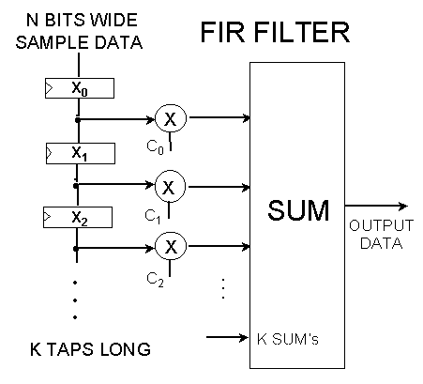Module Generation

From Coregen, Select the SDA Single CHANNEL module under LogiCORE -> DSP -> Filters -> FIR Filters -> Serial Distributed Arithmetic -> SDA FIR Filter single-Channel.

The parameters are the following:

- 8-bit data in, signed
- 12 Taps
- 10-bit coefficient width
- Symmetric
- Maximum output width (21)

Q1) How many CLBs is this filter going to use?

Around 55 CLBs.
Q2) What is the maximum Sample Rate if it is clocked at 70MHz?

70MHz/ (8+1) = 7.8MSPS

Note: SDA FIR process the data serially. This means that it will take at least 8 cycles for an 8 bit data. Since the coefficients are Symmetrical, 2 samples are added together before they get multiplied with the coefficient. Adding two 8-bit numbers together gives a 9 bit output so this SDA FIR Symmetrical filter requires 8 (sample bit width) +1 clock cycle to perform.

End of the Coregen Lab!
Thank you.

